Three Rivers and Watford School Sports Partnership

Rounders League Rules

Playing Area
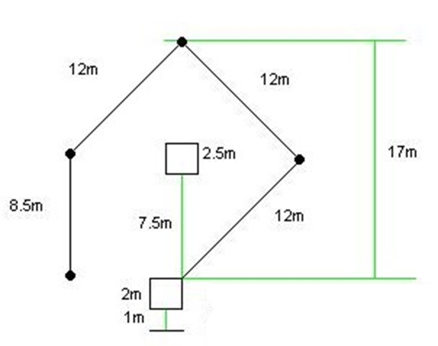

Teams
- Squads must contain between 10 and 12 players
- 9 players play at one time
- Squads can contain a maximum of 5 boys
- Squad must consist of at least 1 bowler, a back stop, a player on each base and three other fielders
- Substitutions may be made at any time in the event of injury or illness
- Substitutions cannot be made if the batter has been struck out when batting
Duration of the Game
- Each game consists of two innings, each inning consists of both teams taking turns batting and fielding
- A two minute interval between batting and fielding should take place
The start
- The captain from each team should toss a coin to determine who decides whether to bat or field first

Scoring
- If the batter reaches the 2nd or 3rd post in one hit, the batting team scores ½ Rounder.
- If the batter reaches 4th post in one hit, the batting team scores a Rounder.
- A batter is out if the fielding team catch the ball hit by a batter before it touches the ground or by touching the post the batter is running to with the ball before the batter reaches it.
- If the runner reaches the 4th post on a no ball, the batting team scores 1 rounder. The batter cannot be caught out.
- 1/2 rounder scored if the 4th post is reached without the batter hitting the ball.
- If the ball goes into the backward area the batter must stay at the 1st post until it reaches the outward area. If the 4th post is reached, 1 rounder is scored.
- If 2nd post is reached before the next ball is bowled, the batting team get 1/2 rounder, but if the batter continues to run and is put out before the 4th post then it is taken off.
- If the batter incurs 2 no balls in a row then a penalty 1/2 rounder is given to the batting team.
- There is a penalty 1/2 rounder given to the batting team if the batter is obstructed by a fielder.
- Teams will score 3 points for a win, 1 for a draw and 0 for a loss
Umpiring
• Each match should have two umpires – One provided from each school
Match Results
• The team with the highest score will win the match.
• Teams will score 3 league points for a win, 1 for a draw and 0 for a loss.
League Results
- All league results must be submitted by the deadline set.
- The team with the highest number of points following completion of all matches will win the league.

